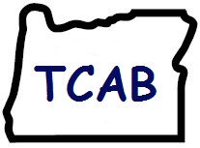

Oregon TCAB
Team Elevator speeches

Harney District Hospital
Burns, OR

“TCAB is the framework that promotes patient centered care by honoring the whole person and family and ensures continuity of care by empowering direct care providers to initiate change that improves clinical outcomes and quality of care.”

Mid-Columbia Medical Center
The Dalles, OR

“TCAB is an opportunity to improve your work environment, enhance patient care, and increase job satisfaction through your ideas. It empowers nursing to address, develop, and transform more effective care processes and promotes the overall vitality of care teams.”

Lake District Hospital
Lakeview, OR

(Made “Transformers” badge cards)

“TCAB is a staff driven initiative to empower transformation of care at the bedside. We welcome suggestions and ideas from all staff, patients, family, and visitors.”

“For every patient, every time. Because good is not good enough.”

“A work group takes an idea, then plans, implements, and evaluates a test project for improvement. After fine tuning, we implement the change large scale.”

Mercy Medical Center
Roseburg, OR

(Made badge cards- “boarding pass”)

“Our unit has been chosen to take part in a National and State initiative called TCAB.”

“TCAB is an opportunity to improve your work environment, improve patient care, and increase job satisfaction through YOUR ideas.”
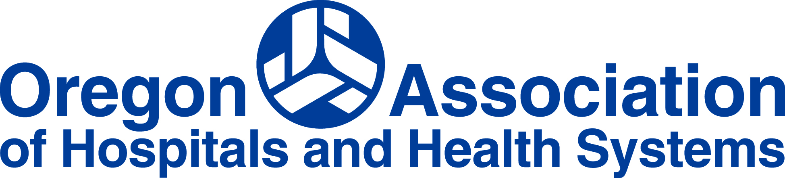
“No idea will go un-noticed. Everyone will be involved. We will consider everything because you have the BEST ideas on how to improve the unit.”

TCAB GOALS
-Improve the quality and safety of patient care
-Increase staff vitality, teamwork, and satisfaction
-Involve patients/families in improving the hospital experience
-Improve the effectiveness of the entire patient care team

Providence St. Vincent Medical Center
Portland, OR

“Transforming Care at the Bedside (TCAB), and Reducing Avoidable Readmission is a shift in the way we work. The essence of TCAB is staff-driven improvements that result from work group teams generating and testing new ideas. TCAB is important to both our staff and patients because it improves engagement and relationships across the continuum of care. Success with our TCAB work will improve patient outcomes and increase time in direct patient care. As a team we need to be open-minded, supportive, empowered, and committed to the processes; have respectful communication; and remain patient-centered.”

Rogue Valley Medical Center
Medford, OR

“TCAB is a change in culture that engages and empowers front line staff to implement tests of change one patient, one nurse, one day at a time by using the Improvement Cycle: Plan, Do, Study, Act. This culture promotes improving the quality and safety of patient care while increasing the vitality and retention of nurses. “

Tillamook County General Hospital
Tillamook, OR

(Made badge cards)

“TCAB is a nurse-led quality improvement program! Tillamook County General Hospital has joined Oregon Alliance to improve patient care! Med/Surg and ICU were selected to take part in this special nationwide initiative to improve patient care.”

Goals:
-Improve quality and safety of patient care in the ICU and medical/surgical units.
-Increase the amount of time caregivers spend with patients.
-Empower nurses and caregivers to make decisions and changes to improve care.

